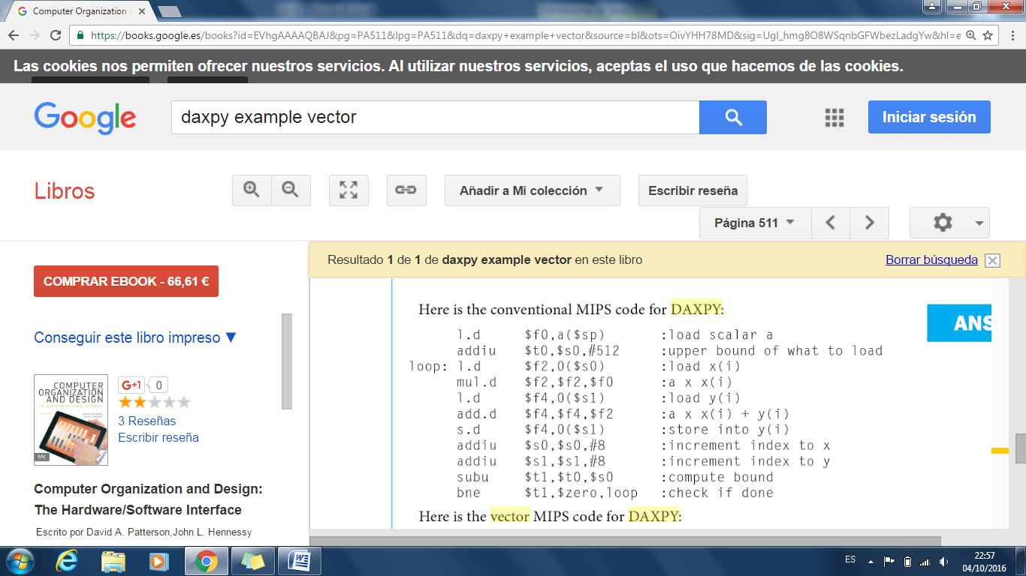

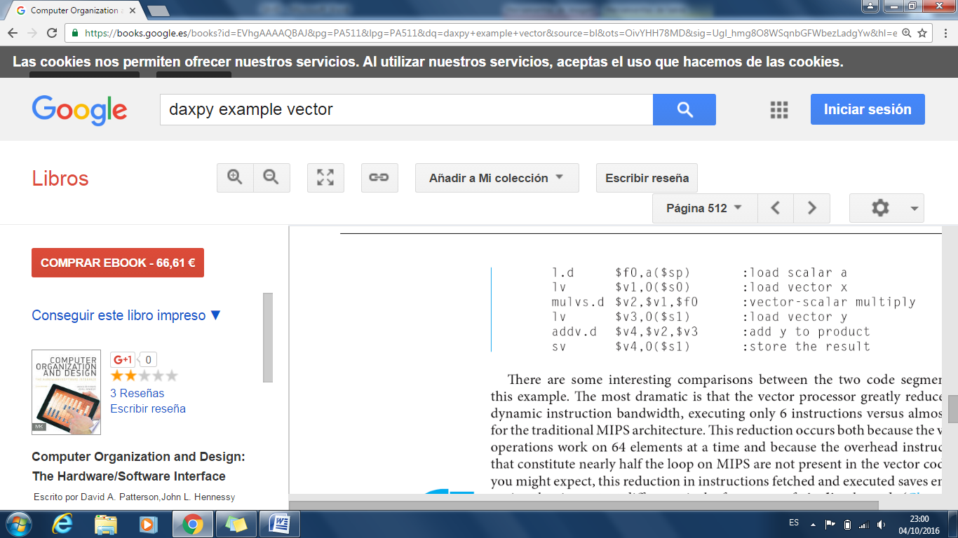

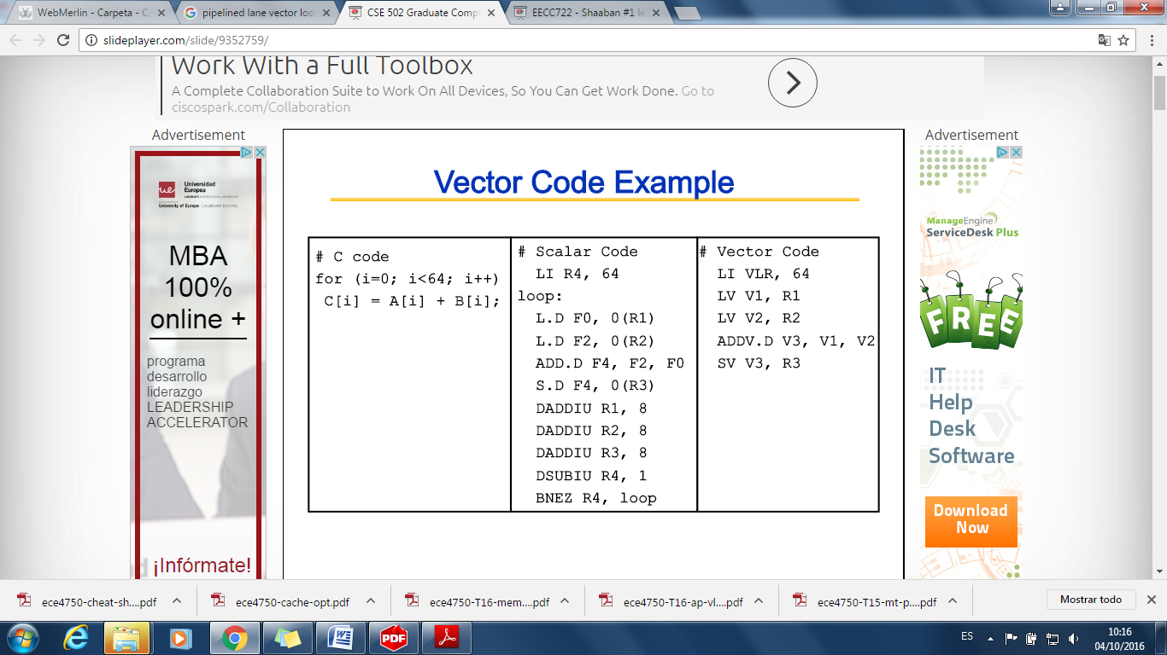

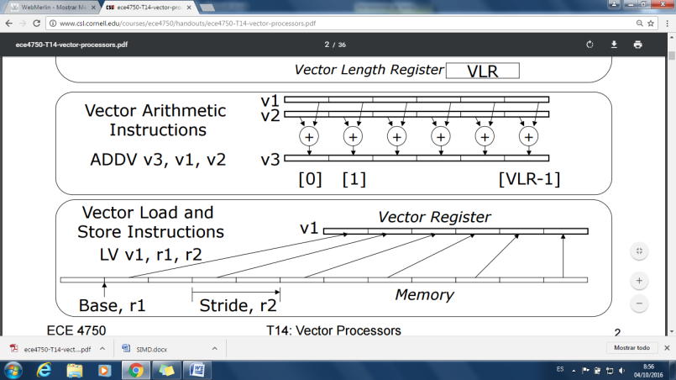

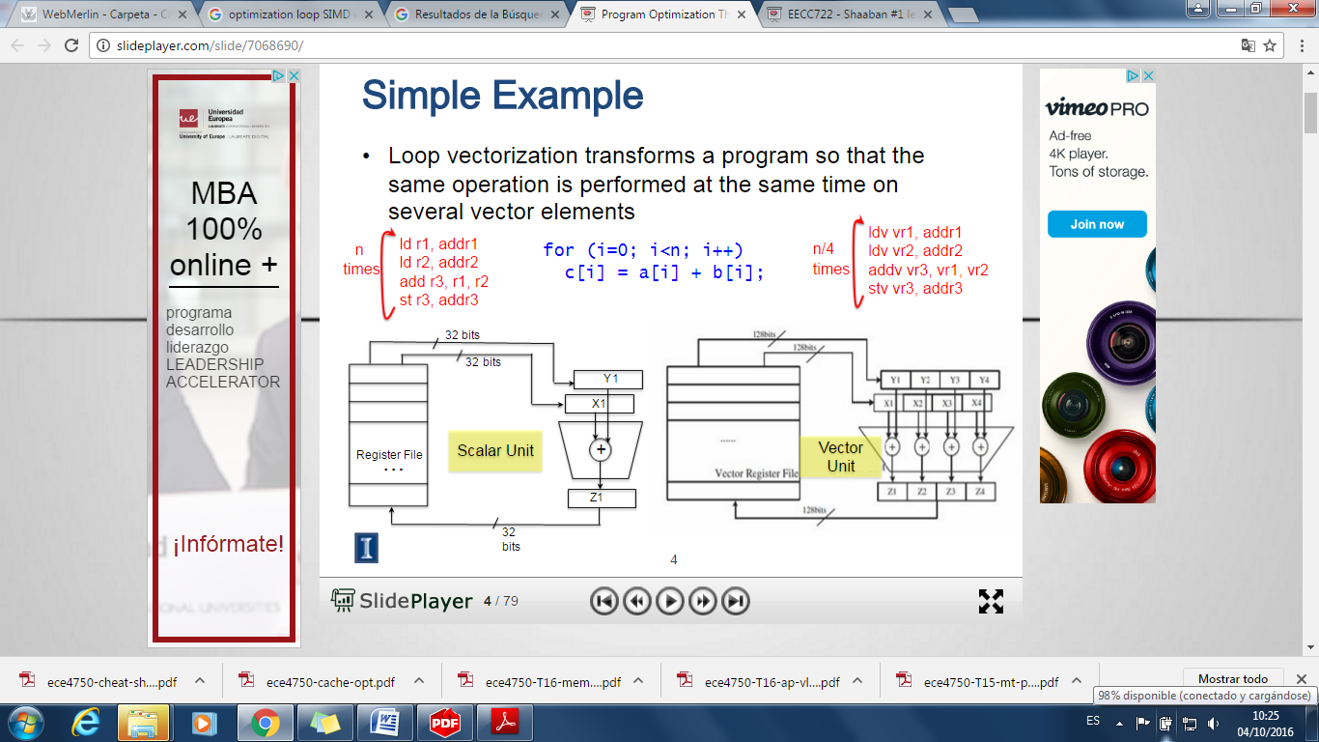

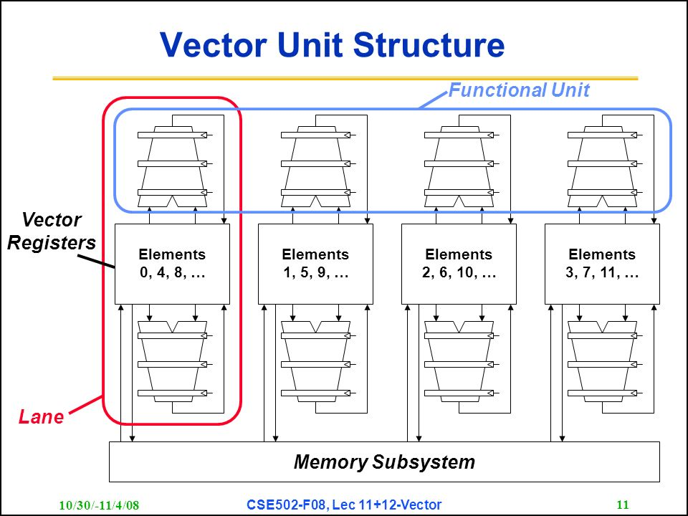

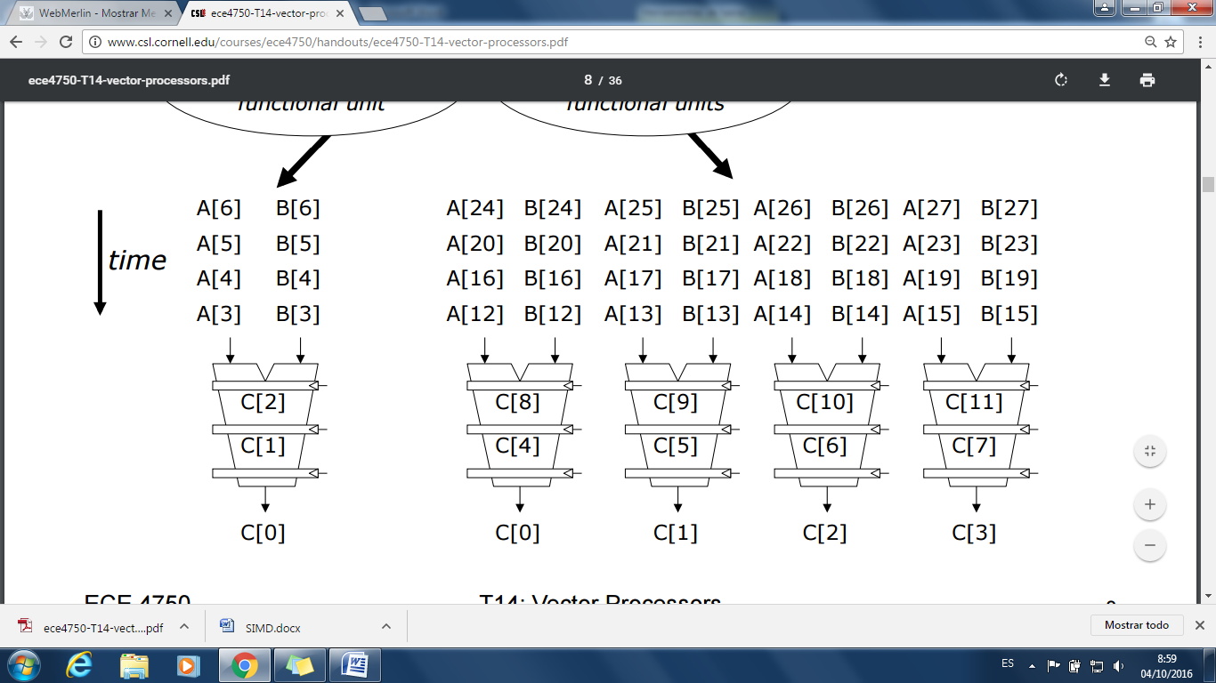

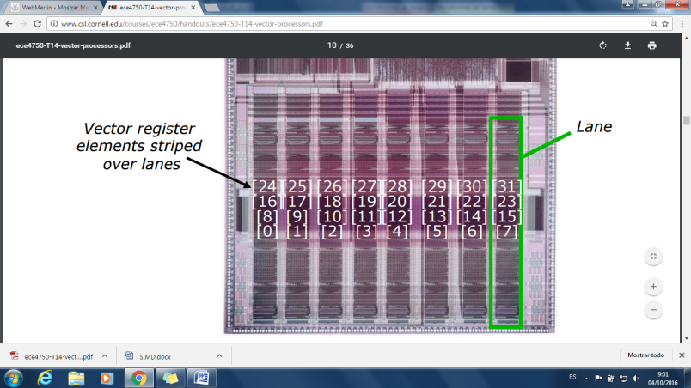

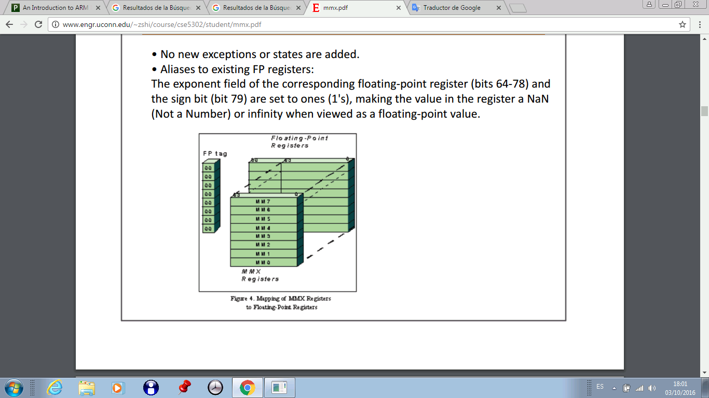

**Paralelismo Subword:**

|  |  |  |  |  |  |  |  |  |  |  |  |  |  |  |  |
| --- | --- | --- | --- | --- | --- | --- | --- | --- | --- | --- | --- | --- | --- | --- | --- |
| 128 b (**double quad word**) | | | | | | | | | | | | | | | |
| 64 b (**quad word**) | | | | | | | | 64 b | | | | | | | |
| 32 b (**double word**) | | | | 32 b | | | | 32 b | | | | 32 b | | | |
| 16 b (**word**) | | 16 b | | 16 b | | 116 b | | 16 b | | 16 b | | 16 b | | 16 b | |
| 8 b | 8 b | 8 b | 8 b | 8 b | 8 b | 8 b | 8 b | 8 b | 8 b | 8 b | 8 b | 8 b | 8 b | 8 b | 8 b |